Envision Tanks

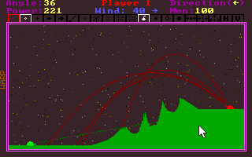

## Task:

Create a small game like tank wars called “Envision Tanks”, where 2 players can fight against each other in turns.

**Use the provided solution to implement your game.**

## Time:

* 1 Week

## Tools:

* Visual Studio
* Programming language: C#

## Submission:

* The whole project with solution in a ZIP file.
* A document with a summary of the project and short descriptions of the created classes and its purpose

Game Design

The game should allow 2 players to play against each other in turns. Each player has a tank in a different color (green/red) which are controlled by keyboard inputs. A player can select a weapon which he wants to use in this turn.

## Turn

A turn has a time limit of 30 seconds. It ends when the time limit is reached or the fired projectile impacts at any tank or terrain or it moves outside of the screen.

## Tank

A tank starts with 100 hit points. Every tank can have a limited number of different weapons. A tank can fire its weapon once per turn. If a tank has 0 hit points it is considered dead. The game ends when only one tank is left. Movement of tanks is not a required feature.

## Weapon/Projectile

A weapon has a start angle, a defined amount of shots and a min and max start velocity. The shot amount can be “-1” (infinite) or > “0” for a limited amount. A weapon fires at least one projectile per shot. A projectile uses a simple ballistic trajectory which is influenced by gravity and wind (optional).

Implement at least two weapons with different projectiles, one which makes damage and one other projectile. All weapons and projectiles should be loaded from an xml file.

## Terrain

The terrain should be dynamically generated. Its surface is a compilation of curves and straight lines where the tanks can be placed. For simplicity the terrain is not destroyable.

## Game UI

The following information should be shown:

* turn time left
* active player name
* hit points of all tanks
* all available weapons of the current active tank
* weapon angle of the current active tank

## Input

The Up/Down-Arrow keys adjust the weapon start angle. By pressing and holding the space key the player defines the velocity of the projectile between min and max velocity of the selected weapon